

**Kallam Haranadhareddy Institute of Technology**

**Retail Management Application Using Salesforce**

**By**

**V. Anitha**

[**218x1a4434@khitguntur.ac.in**](mailto:218x1a4434@khitguntur.ac.in)

**G. Likhitha Krishna**

[**218x1a4411@khitguntur.ac.in**](mailto:218x1a4411@khitguntur.ac.in)

**M. Anji Kumar**

[**218x1a4457@khitguntur.ac.in**](mailto:218x1a4457@khitguntur.ac.in)

**R.B.B.Maruthi Sai**

[**218x1a4426@khitguntur.ac.in**](mailto:218x1a4426@khitguntur.ac.in)

**Project Abstract**

This project is focused on creating a Retail Management Application Using Salesforce designed to address. The goal is to deliver a comprehensive solution by leveraging Retailing, which encompasses the business activities involved in selling goods and services to consumers for their personal, family, or household, etc. We created an app called sales app for the pupose of Managing the customer data as well as inventory Data.

### **Introduction**

The retail industry requires efficient solutions to manage sales, inventory, and customer interactions. This project leverages Salesforce CRM to provide a cloud-based retail management

### **Objectives**

* **Customer Management**: Store and manage customer details, preferences, and purchase history.
* **Product Management**: Maintain inventory details, stock levels, and pricing information.
* **Sales Management**: Track transactions, generate invoices, and analyze sales trends.
* **Reports and Dashboards**: Provide insights into revenue, customer behavior, and product performance.
* **Automations**: Implement workflows to streamline order processing and notifications.

### **Methodology**

1. **Requirement Analysis** – Understanding retail business needs.
2. **System Design** – Designing objects, relationships, and data models in Salesforce.
3. **Implementation** – Developing objects, reports, dashboards, and automation workflows.
4. **Testing & Deployment** – Ensuring the system meets business objectives before deployment.

### **Step-by-Step Implementation**

#### **1. Introduction & Creation of Salesforce Org**

* **Sign up for Salesforce Developer Edition** at [Salesforce Developer](https://developer.salesforce.com/signup).
* **Login to Salesforce** and navigate to **Setup**.
* **Create a New Org** for the retail management project.
* Define the **Org Name, Domain, and Admin Credentials**.
* Configure basic settings like **Locale, Language, and Time Zone**

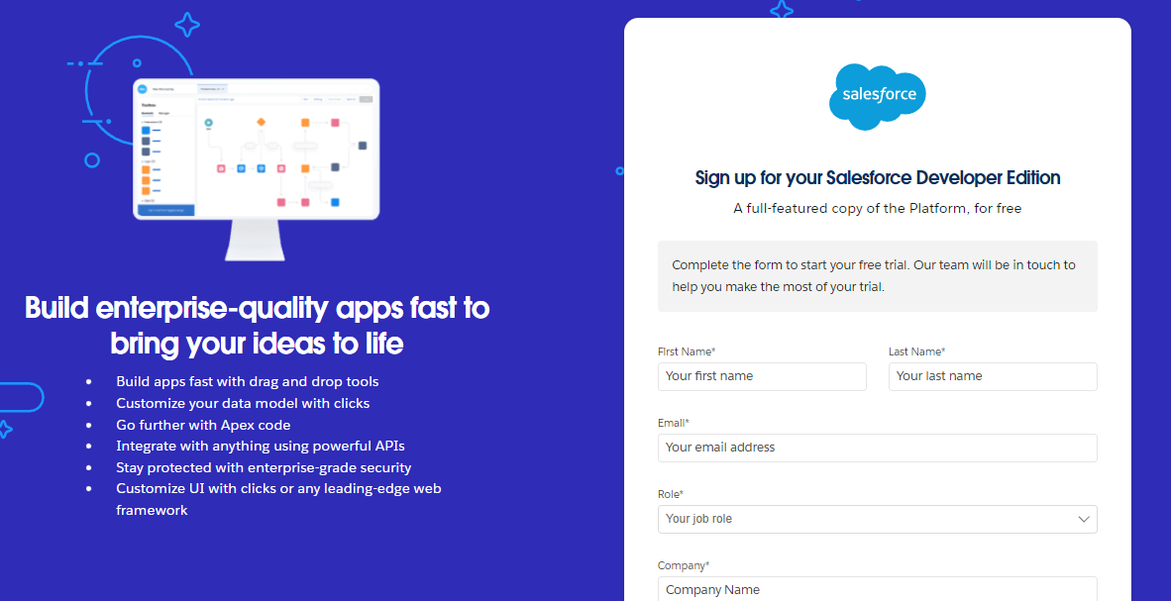

#### **2. Object Creation**

* Go to **Setup > Object Manager**.
* Created objects for:
  + **Tracking**
  + **WareHouse**
  + **Sales Order**

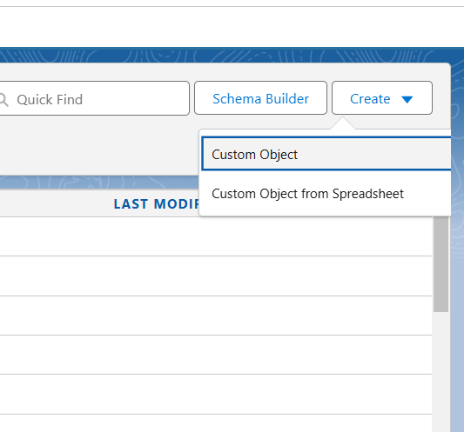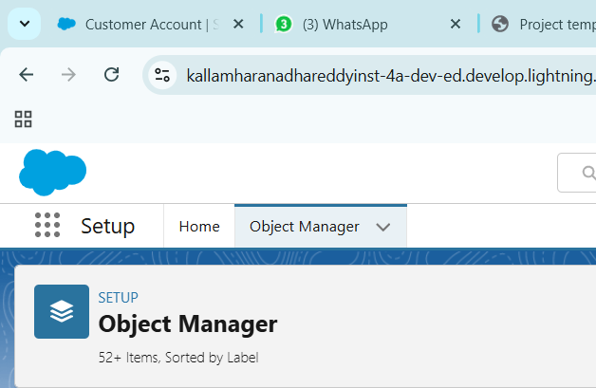

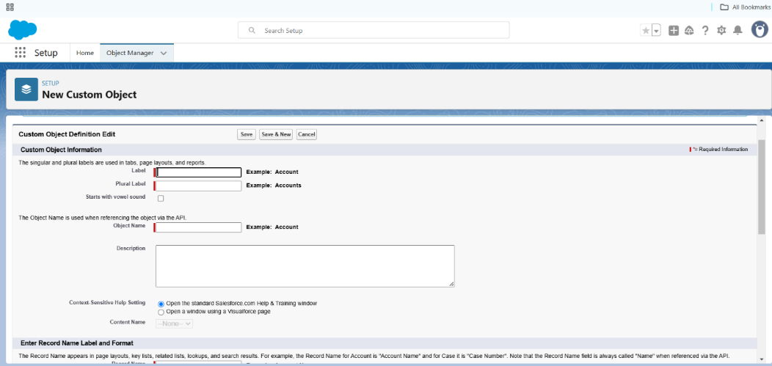

#### **3. Creating Tabs for the Objects**

* Created Tabs for All the Objects Created

#### **4. Sales App Creation**

* Created A Sales App in Lightning App Builder For the Sales End.
* 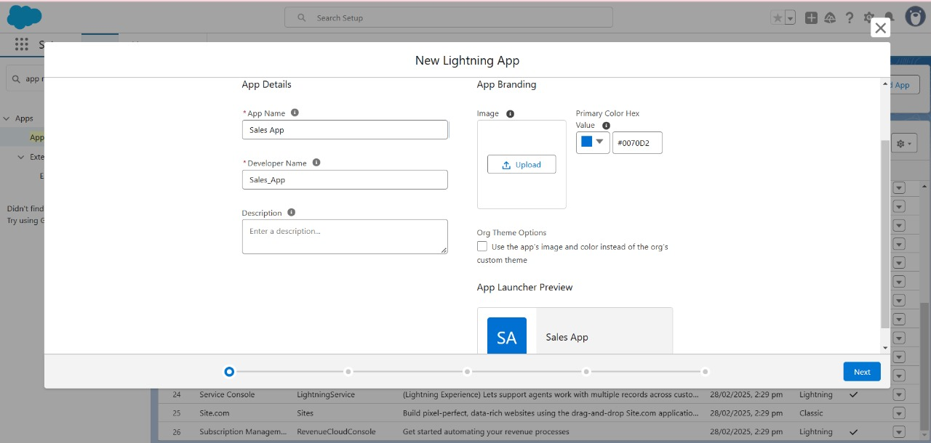Included the Objects warehouses, Sales Orders, Tracking, etc.,

#### **5. Fields and Relationships**

* Created Fields and Relationships
* fields for the Dispatch/Tracking object
* master-detail relationship on Tracking object
* PickList Field on Sales Order
* Lookup relationship on the Sales Order object the Account object
* 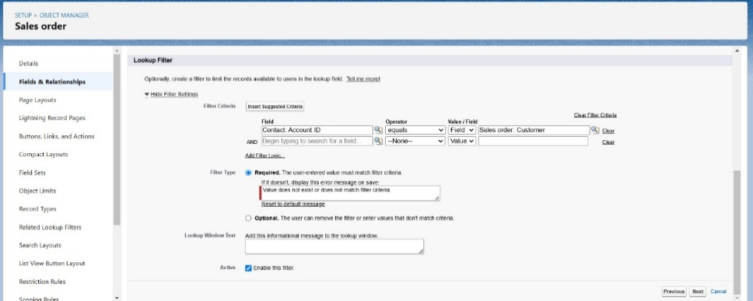Lookup relationship on Sales Order object with Contact object with use of Lookup Filter

.

#### **6. User Management**

* A user is anyone who logs in to Salesforce
* 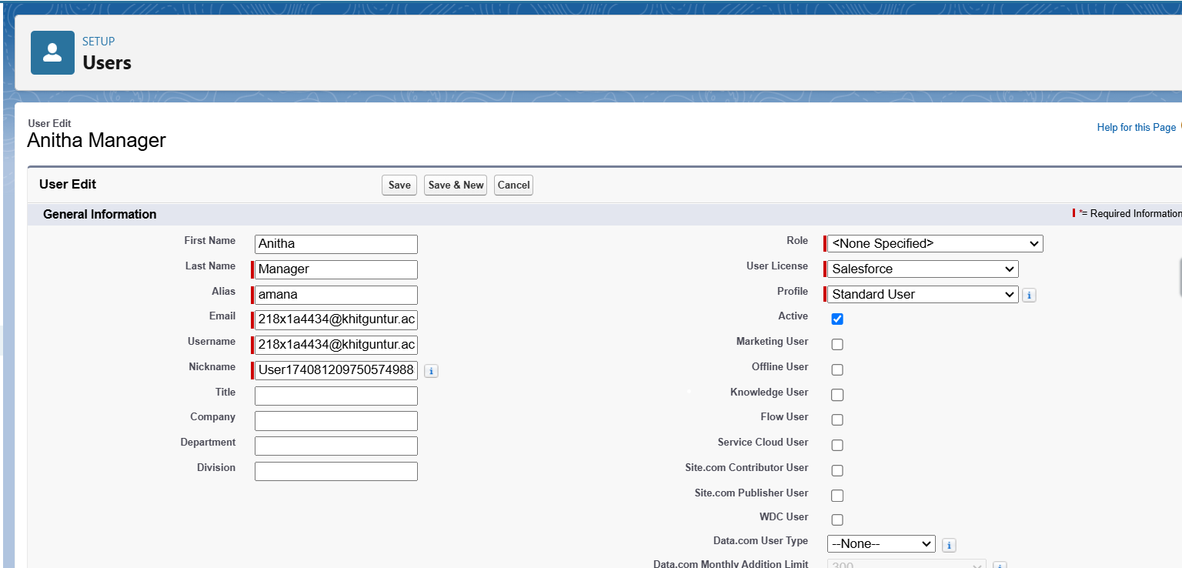Creating User is The Next Step

#### **7. Validation Rules**

* 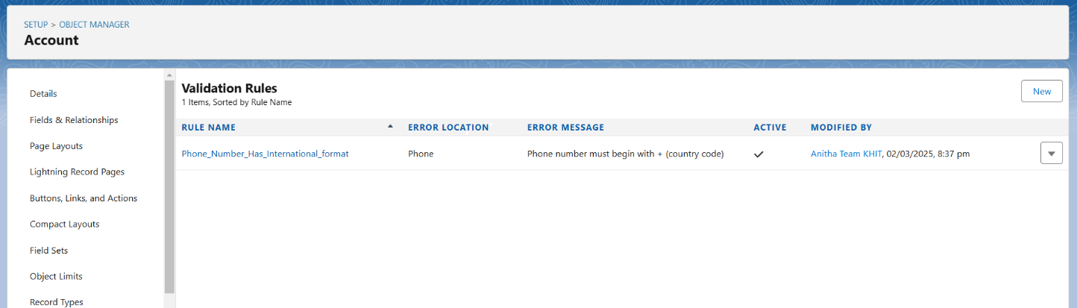Validation rules verify that the data a user enters in a record meets the standards you specify before the user can save the record

#### **8. User Adoption**

* So let's test The sales App
* Create Record
* View Record
* Delete Record

#### **9. Reports and Dashboard**

* Reports in Salesforce is a list of records that meet a particular criterion which gives an answer to a particular question.

#### 

* 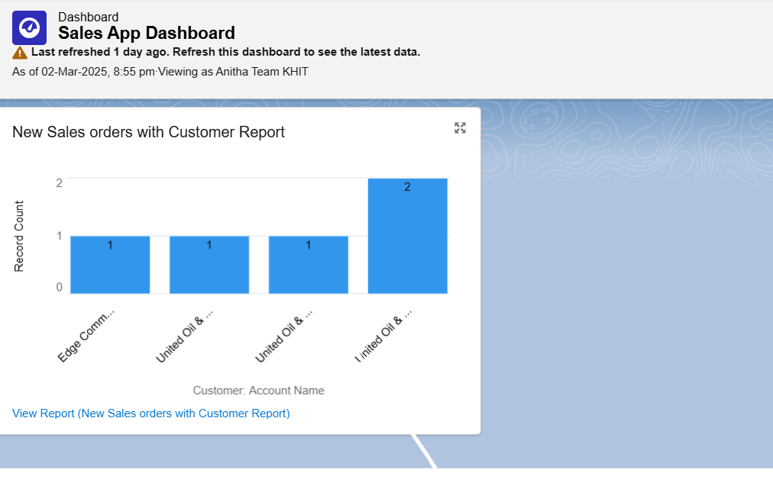We Use dashboards to visualize data.

#### **10. Automation (Flows & Triggers)**

* Created Flows to Create Lightning home page
* To send an email alert to the customer once order is confirmed
* To Create Record trigger flow

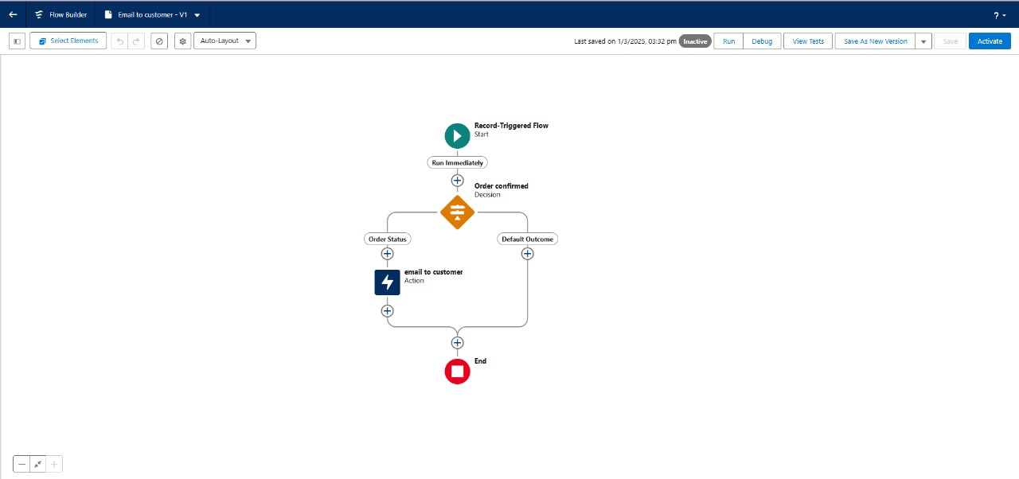

* A Trigger is a segment of Apex code that executes before or after inserting or modifying a Salesforce record based on the condition provided.
* We Created Trigger on account to prevent Duplicate Name

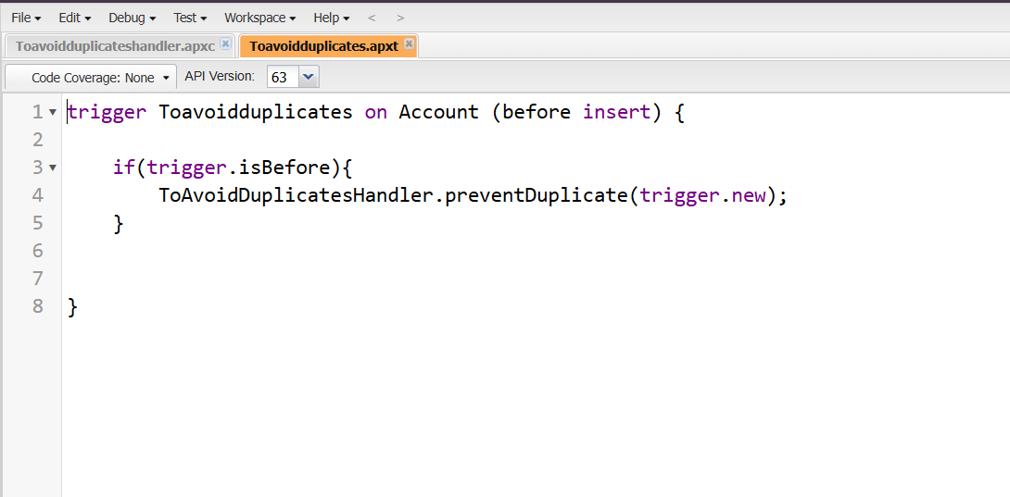

6. Benefits

* Streamlined retail operations with automated processes.
* Improved customer engagement and retention.
* Data-driven decision-making with real-time analytics.
* Enhanced scalability and flexibility with cloud-based solutions.

### **Future Recommendations**

* **Integration with Payment Gateways** – Enable direct transactions from Salesforce.
* **Mobile App Integration** – Provide accessibility on mobile devices.

### **Conclusion**

This project successfully implements a retail management system using Salesforce, improving efficiency in sales operations, inventory tracking, and customer management. Future enhancements can further optimize business growth.

**THANK YOU**